**Services & Daemons**

Daemons are the programs that run in the background performing various tasks.

**Start and Stop services**

To start the services

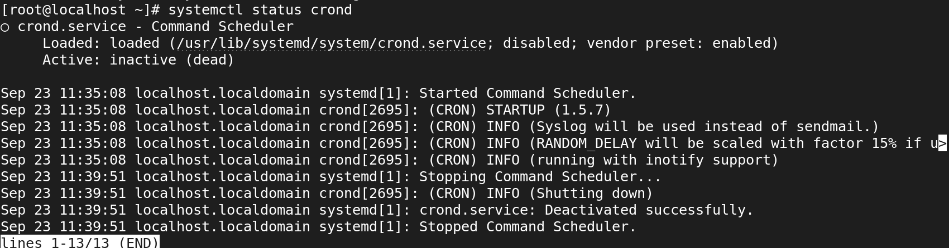

=-09876re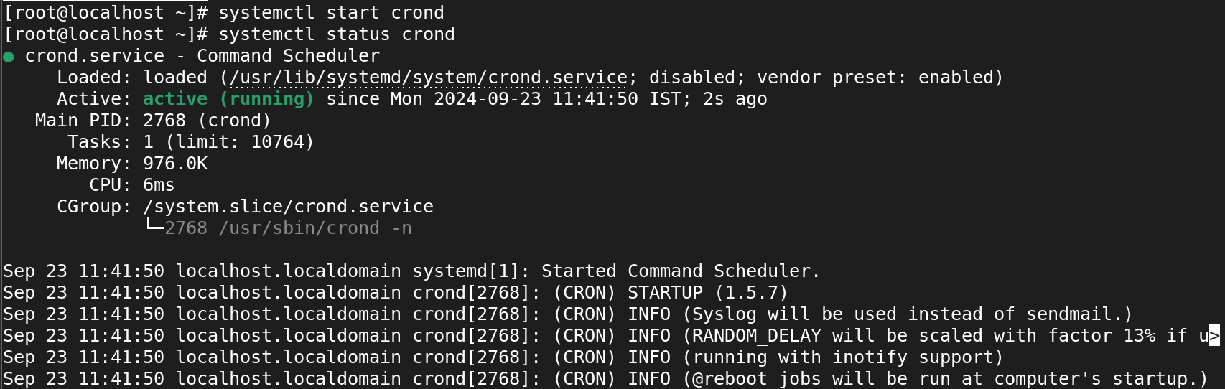

To stop the services.

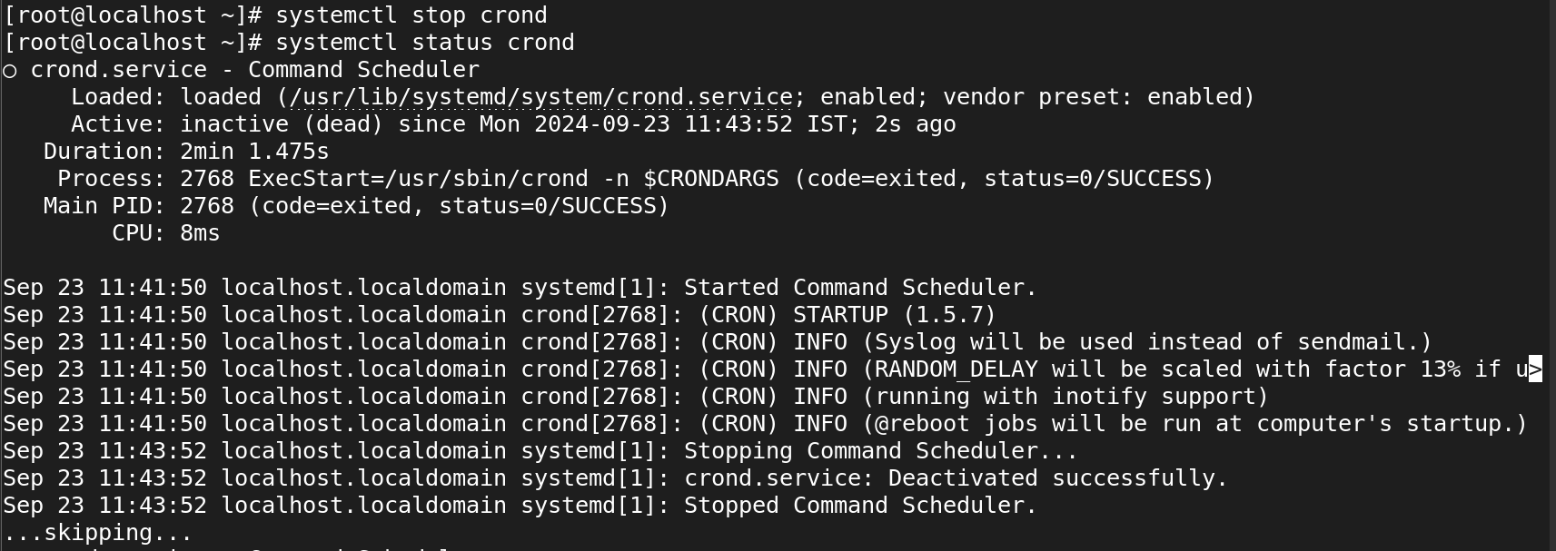

**Enable and Disable services**

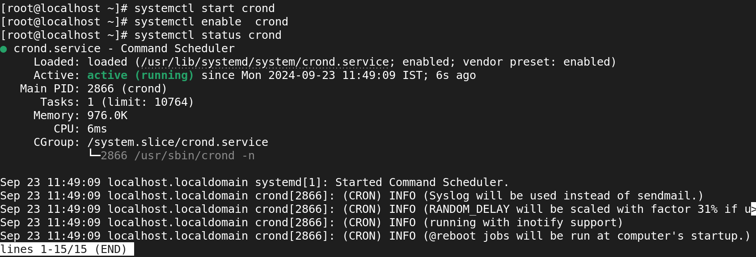

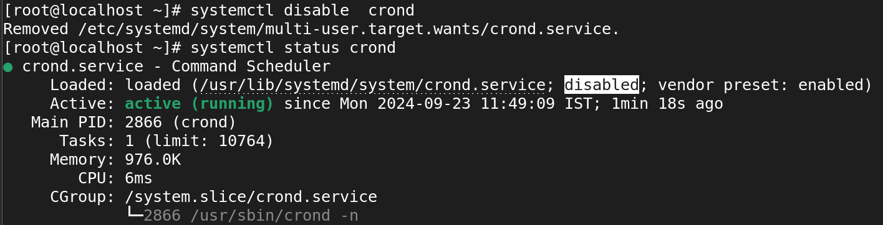

We can activate and enable by using single command.

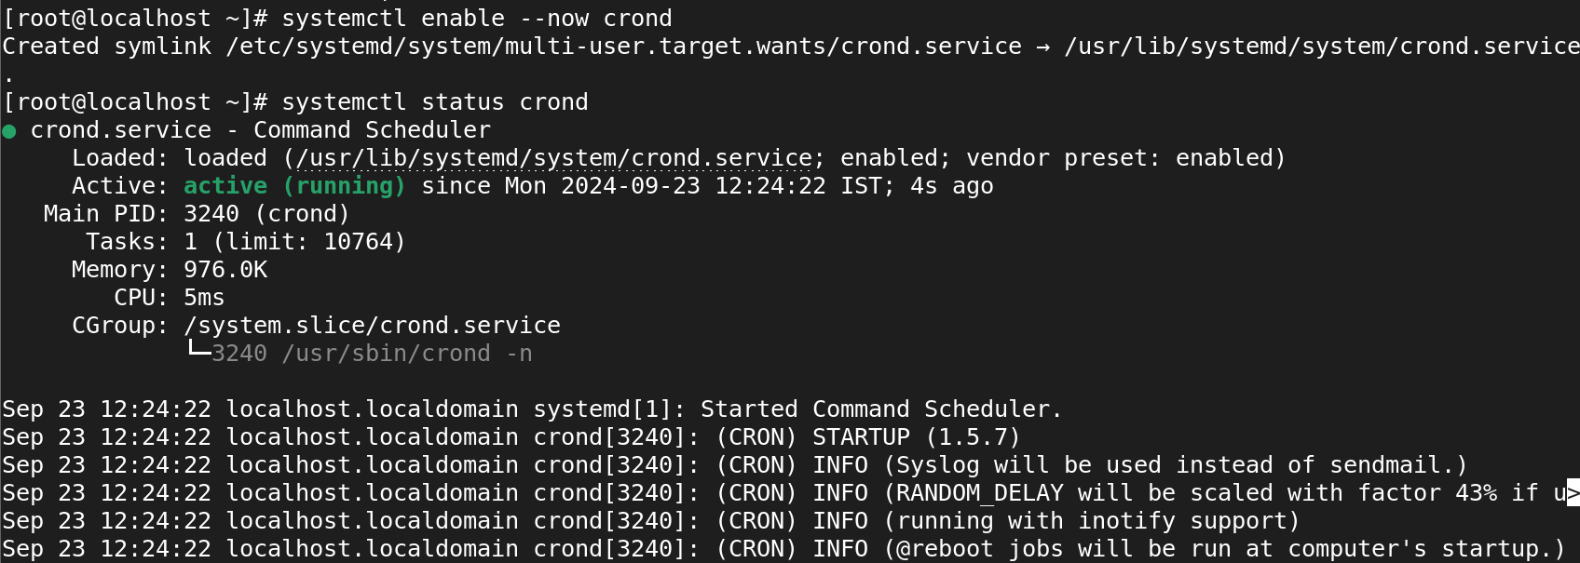

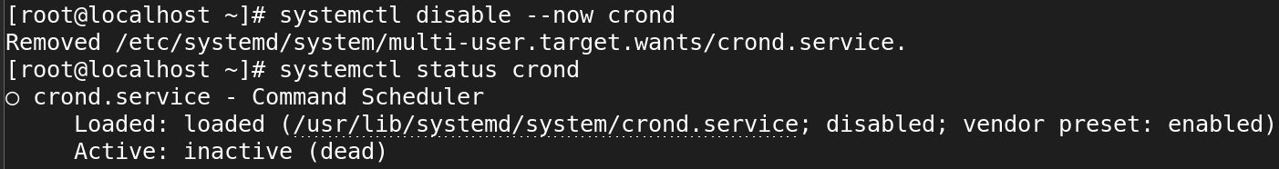

**List all the units**

**# systemctl list-units -all**

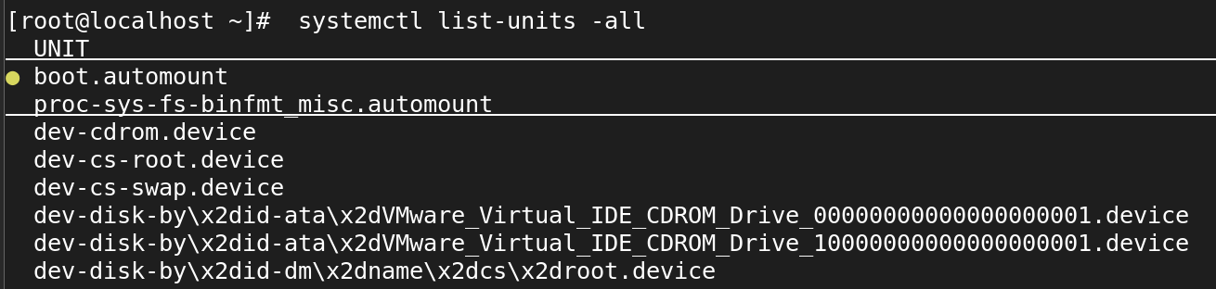

**List all services**

**# systemctl list-units --type service –all**

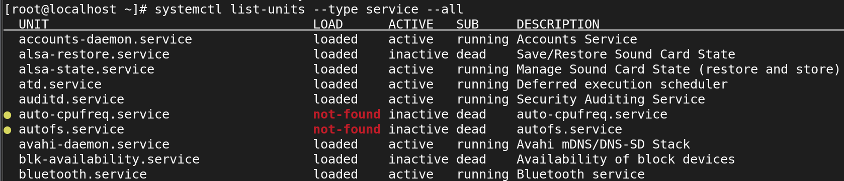

**# systemctl list-unit-files --type=service**

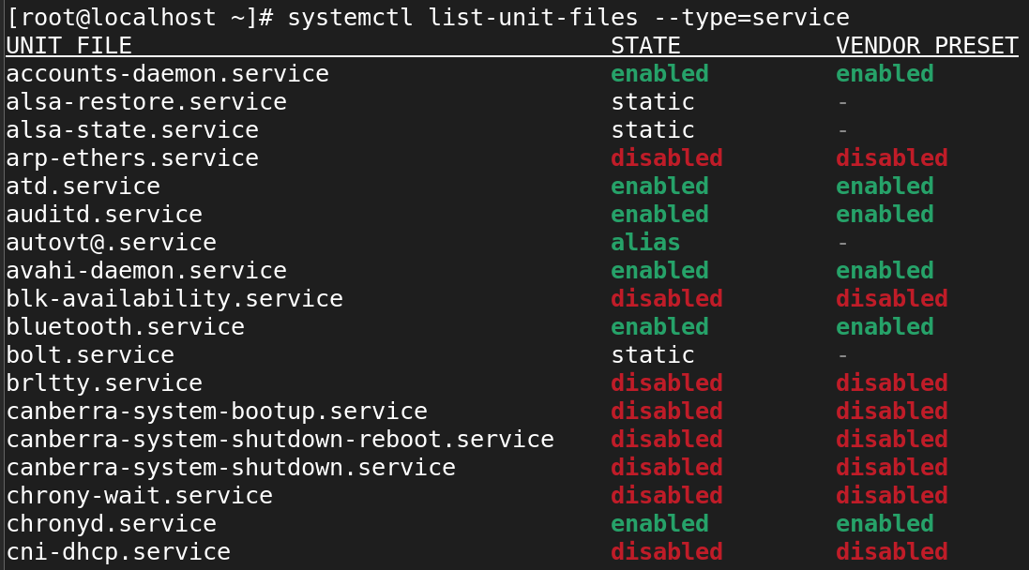

list of services that are active now

**# systemctl -t service**

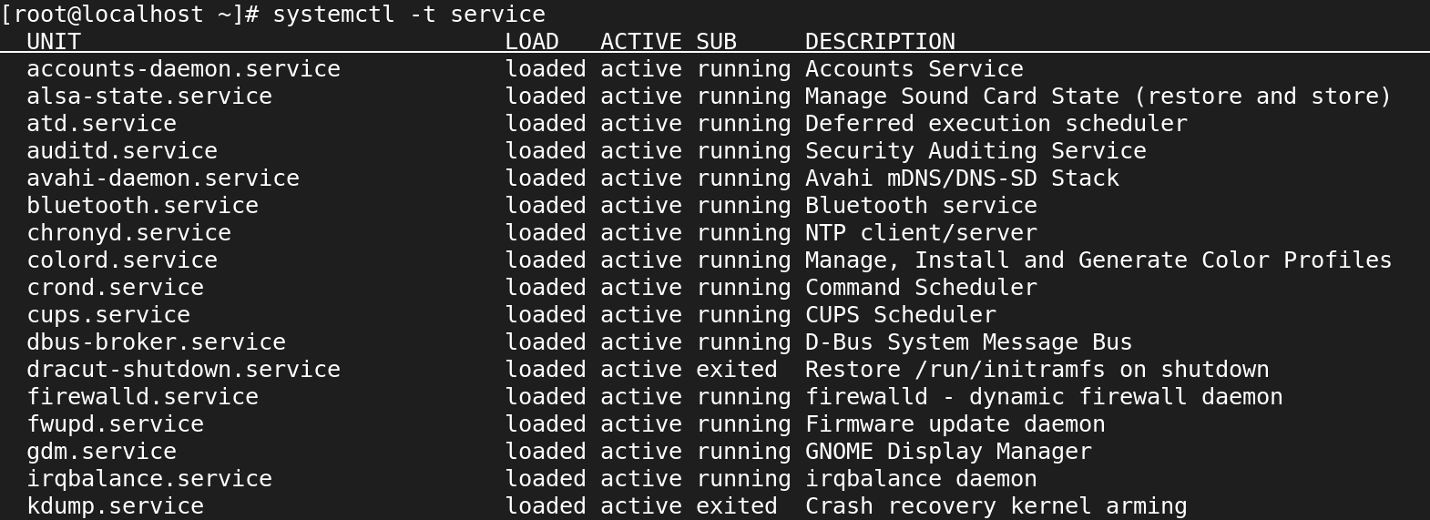

Reload Unit Files

**# systemctl daemon-reload**

**Start and Stop services**

**# service <service name> start/stop**

**# service firewalld start**

**# service firewalld stop**

**# service firewalld status**

**Restart and Reload services**

**# service <service name> restart/reload**

**# service crond restart**

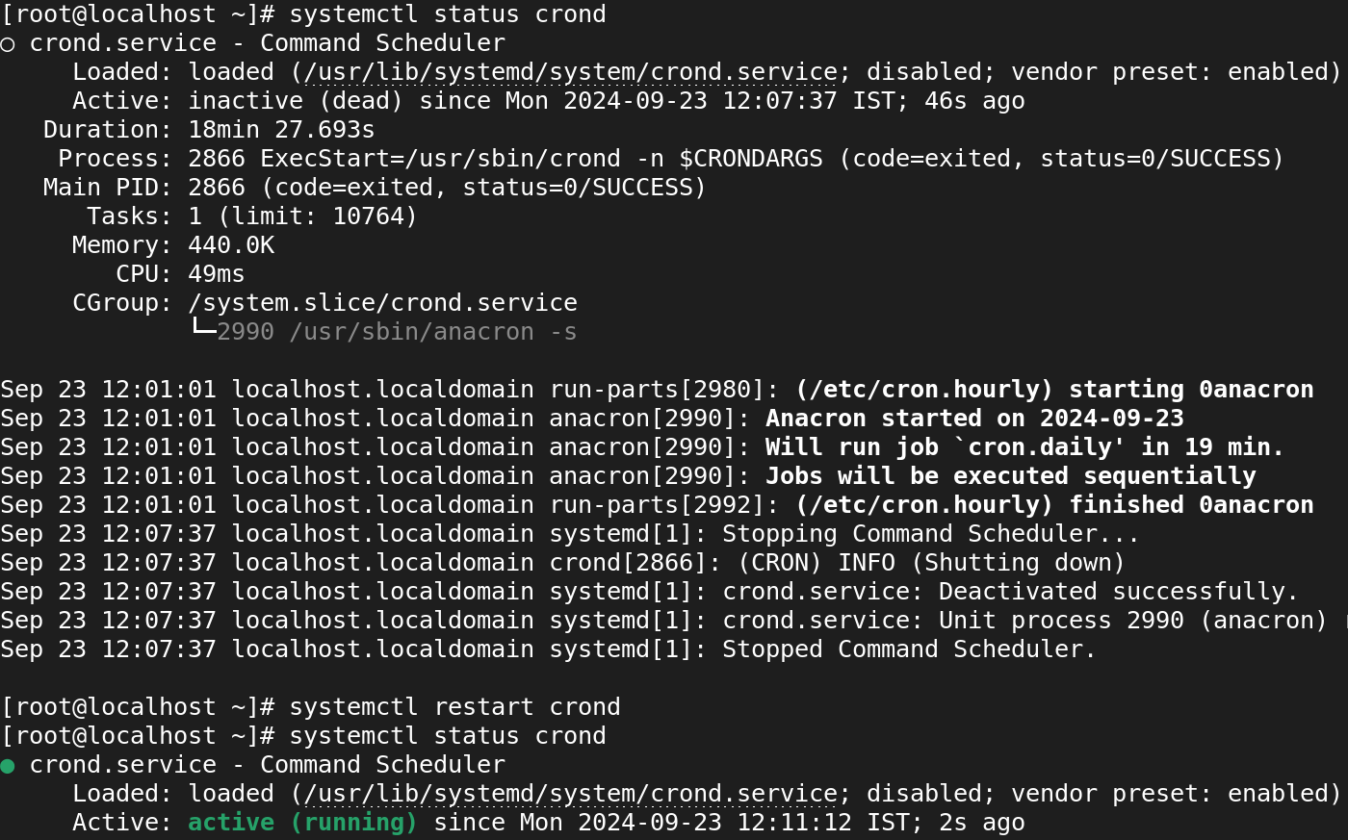

**# service crond reload**

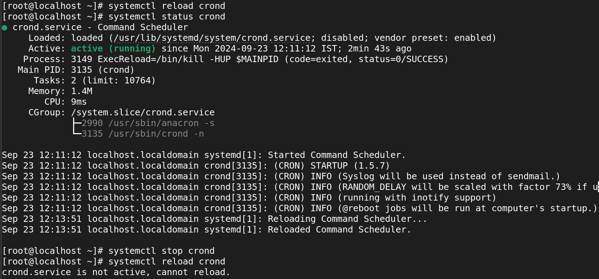

RHEL/OEL/CentOS – 6

=======================

**Start and Stop services**

#service <service name> start/stop

#service crond start

#service crond stop

#service httpd status

#/etc/init.d/crond start

#/etc/init.d/httpd stop

**Restart and Reload services**

#service <service name> restart/reload

#service crond restart

#service crond reload

#service httpd restart